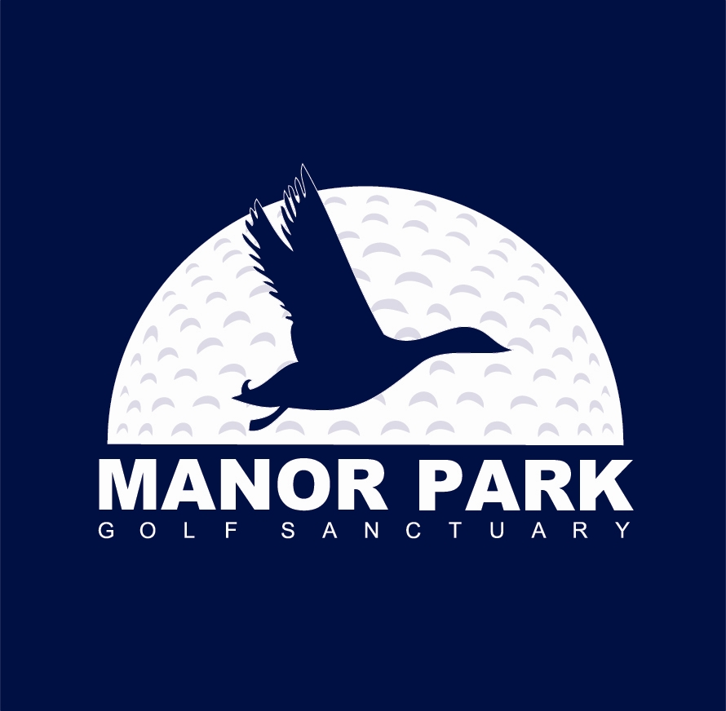

OLIVER CUP
Wednesday 6th February 2019

Men and Women

36 hole Strokeplay Event

Events
- 36 Hole Gross Prize and Runners-up (Mens Div 1 & Div 2, and Women)
- 36 Hole Nett Prize and Runners-up (Mens Div 1 & Div 2, and Women)
- AM and PM Gross and Nett Prizes
- Longest Drive – 8th Hole over the 2 rounds – All
- Nearest Pin – 2nd Hole over the 2 rounds for Men and 11th for Women.
- One prize per player except for longest drive and nearest to pin.
- Two’s

Conditions of Entry

- MAXIMUM OFFICIAL NZGA HANDICAP – 15.00

- ENTRY FEE :- $60.00 - The use of electric carts and motorised vehicles is not permitted. Packed lunch included.

- Play will be in 3’s – 75 lowest handicapped paid entries

- Entries via phone or e-mail to Manor Park Golf Sanctuary by 5.00pm on Friday 1st February 2019, or online through WGI. Manor Park members can enter online via our website: manorparkgolf.co.nz

- Tel: 04 563 8558 Email: office@manorparkgolf.co.nz


