MARTINBOROUGH GOLF CLUB
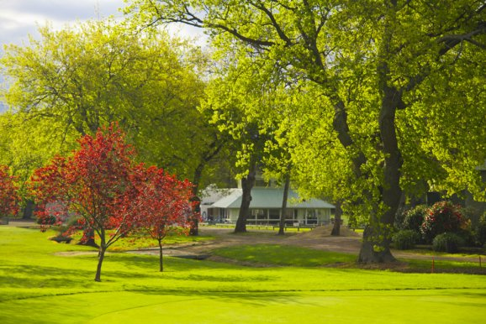
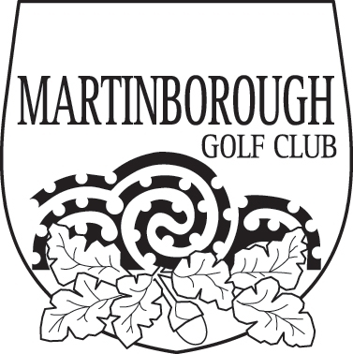

“THE BOTTLE-O” LEFTIES / RIGHTIES 36 HOLE TOURNAMENT
SATURDAY, 17 AUGUST 2019 (RESERVE DAY – SUNDAY 18TH)

OPEN TO MEN, WOMEN, MIXED PAIRS & JUNIORS
Divisions for Best Gross & Nett
All players must be an affiliated member of a registered Golf Club
and have a current NZGA Handicap

Entry Fee - $40 per person (includes lunch)
(Entries close Thursday, 15 August @ 4 pm)
Please report by 8.00 am for a shotgun start at 8.30 am

Entries to -
Martinborough Golf Club
P O Box 4
Martinborough
Telephone: (06) 306 9076
Email office@martinboroughgolfclub.co.nz

Please complete the entry form below and return with entry fee of $40 per person (lunch included).

Leftie…………………………………………Club ID………………………Hcp…………

Rightie……………………………………….Club ID……………………….Hcp………...

Address, phone number and email of one player:

Name ……………………………………………….

Address………………………………………………………………………………………………………….
Phone ……………………………………………….

Email …………………………………………………..

