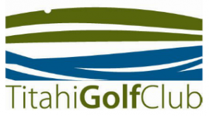

KELLY HYGIENE NZ OPEN

Saturday November 27th 2021

- Trophy for best overall net
- Quality prizes
- Net - Gross – stableford
- $45 entry fee (includes two’s and light meal)
- Monster Ham Raffle

Other Sponsors:
- Whriday Whrites
- Kemsol
- Plumbing World
- Mitre 10 Porirua

Entries to Tom Campbell: 021 512714, titahigolf@xtra.co.nz. Pay entry direct to 03 0547 0890051 02

